The Mortgage Box

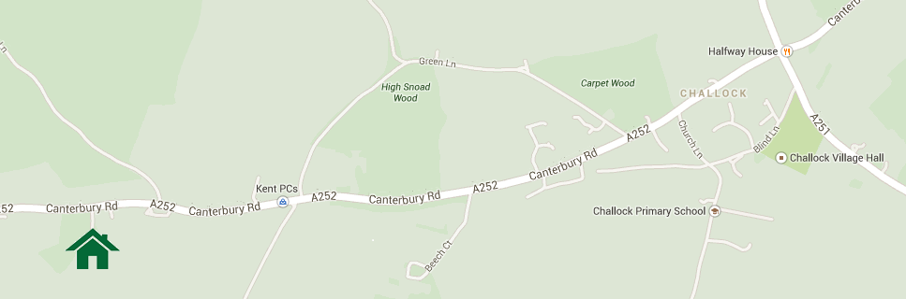
Dormers Annexe, Pays Lane, Canterbury Road, Challock, Ashford, Kent TN25 4DW

How to find us:

With a Sat Nav, key in exactly: ‘Pays Lane, TN25 4DW’ and this will bring you to Dormers.

From Canterbury: (approx. 20-25 mins)

- Head towards Ashford through Wincheap on the A28
- Continue on A28, through Chilham, Molash until you reach Halfway House roundabout in Challock – your now 4 mins away.
- Go over the roundabout, continuing on A252 towards Charing/Maidstone
- All on your left is the village green, then you’ll see Landmark Range Rover, then Little Paddock Farm, at the end of Little Paddock Farm’s fence, turn sharp left into the woods. This is Pays Lane and come through gates, past house and drive up to blue Annexe. Park and go up the wooden stairs.

From Faversham: (20 mins)
- Head towards Ashford on the A251 Ashford Road
- Take 3rd exit at the Halfway House roundabout turning right onto A252 Canterbury Rd.
- All on your left is the village green, then you’ll see Landmark Range Rover, then Little Paddock Farm, at the end of Little Paddock Farm’s fence, turn sharp left into the woods. This is Pays Lane and come through gates, past house and drive up to blue Annexe. Park and go up the wooden stairs.

From Ashford: (20 mins)
- Head towards Faversham/Canterbury on the A251, Faversham Road
- Take the first exit at the Halfway House roundabout, turning left onto the A252 Canterbury Road
- All on your left is the village green, then you’ll see Landmark Range Rover, then Little Paddock Farm, at the end of Little Paddock Farm’s fence, turn sharp left into the woods. This is Pays Lane and come through gates, past house and drive up to blue Annexe. Park and go up the wooden stairs.

From Maidstone/Ashford: (20 mins)
- Head towards Charing using the A20
- At Charing roundabout, take the first exit onto the A252 Northern Bypass/ Canterbury Road
- The turning for Dormers will be on the right, just before the short wooden fence of Little Paddock Farm who are our neighbours. You’re turning into the woods adjoining their fence. (This is Pays Lane).

